From Life-Saving Devices to Circular Design: New Designers 2026 Crowns Its Winners
This year's winners – working across innovation, textiles, jewellery, ceramics and furniture – prove that today's new designers are as driven by purpose as by craft

1-4th July
Business Design Centre
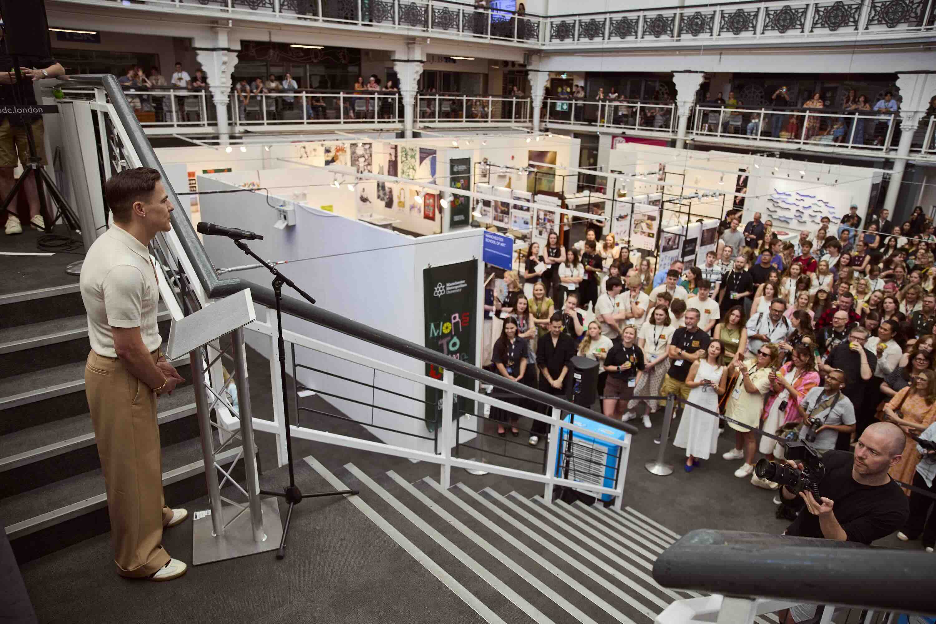
Above: Lee Broom, Guest speaker at the award ceremony

LONDON (2 July 2026) – The UK’s biggest graduate show New Designers opened yesterday with its new one-week format at London’s Business Design Centre. This annual event celebrates the best emerging talent in the UK, featuring over 2,500 design graduates from more than 100 university courses – get tickets now. The event focuses on various disciplines, including Fashion and Costume, Contemporary Design Crafts, Textiles, Ceramics, Glass, and Jewellery and Metalwork. The awards event was opened by one of the world’s leading designers and artists, Lee Broom. He honoured a group of exciting graduates with 19 accolades supported by international brands and businesses as part of the show’s ND Awards programme.

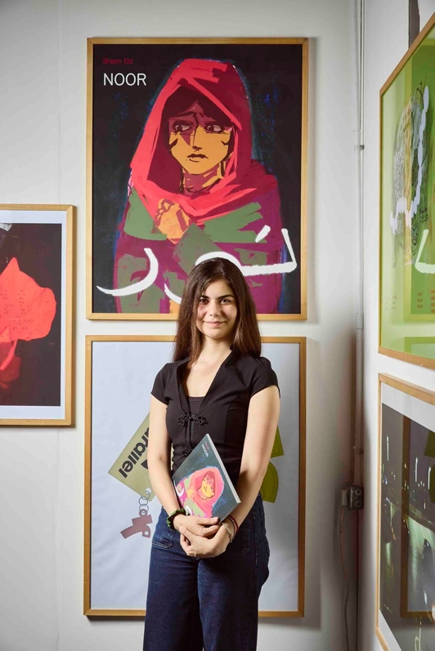
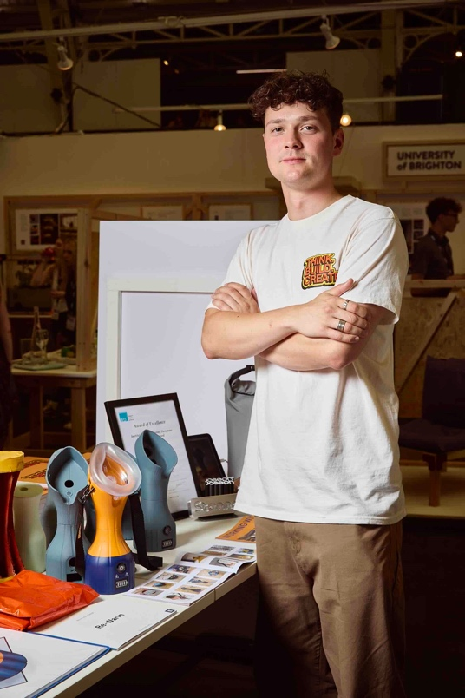

Above (from left): Rupert Murphy from Bournemouth University, and Sharm Eid from Cambridge School of Visual & Performing Arts, the winner and runner up of the BDC New Designer of the Year Award

BDC New Designer of the Year
Rupert Murphy of Bournemouth University won the prestigious BDC Designer of the Year Award for Re-Warm. Re-Warm is a portable rescue device designed for the critical minutes after cold water recovery. It targets an overlooked pathway – the airway. By supplying warmed, humidified air through the casualty’s natural breathing, it reduces respiratory cooling. Supports gradual rewarming.

The jury commented “Design at its best – honest intentional and obvious, and saving lives whilst doing.”

BDC New Designer of the Year Runner-Up
Sharm Eid from Cambridge School of Visual & Performing Arts has created ‘Noor’, a graphic novel about a young girl leaving her country due to the impact of war, and her family’s experience of moving to England. The story is loosely based on Shiam’s childhood in Libya and settlement in the UK. The novel uses a combination of digital painting and handmade textures.

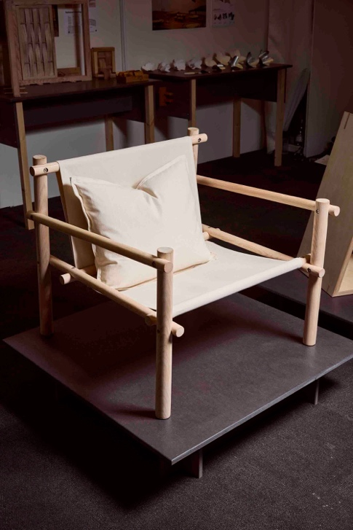
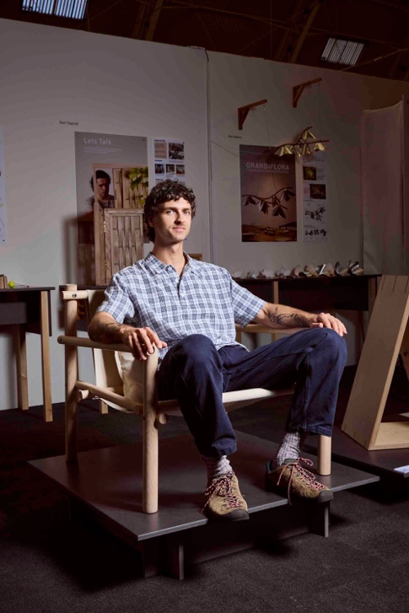

Above: Tyler Lamber from Bath Spa University, winner of the Allermuir Next Generation Furniture Award

Allermuir Next Generation Furniture Award
Tyler Lambert of Bath Spa University received the Allermuir Next Generation Furniture Award for Modo, a contemporary luxury armchair developed in response to a Porada brief.
Moving away from foam-heavy upholstery, Modo features a refined, stripped-back aesthetic with off-the-shelf fixings to reduce manufacturing costs and make high-quality furniture more accessible to a younger market. The chair is crafted from ash sourced from felled campus trees and finished with unbleached cotton canvas, demonstrating a thoughtful approach to sustainable design.
Tyler said: "This award is a real stepping stone into the industry. I've long admired Allermuir, so receiving this recognition means even more."
The judges praised the chair's commercial viability, sustainable material choices and the professionalism of its presentation at New Designers.
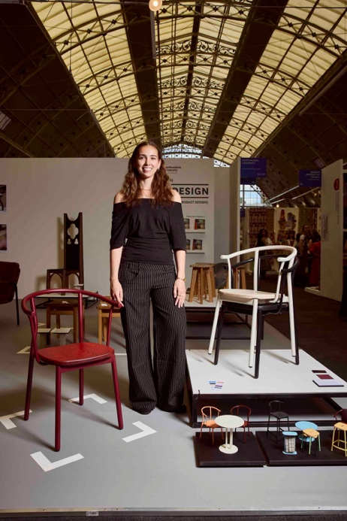
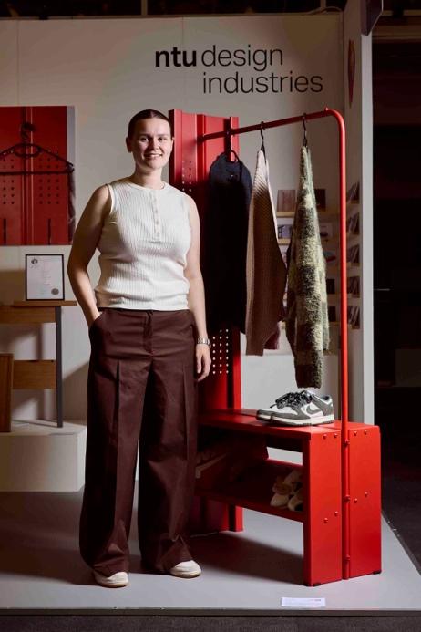

Above (from left): Becca Panter from Nottingham Trent University, winner of The Conran Shop Design Award, and Elora Foley from Northumbria University, winner of the John Lewes Award for Design Innovation

The Conran Shop Design Award
Becca Panter of Nottingham Trent University won The Conran Shop Design Award for ReFrame, an innovative clothing storage system addressing the realities of compact student living.
Developed in response to a Habitat brief, Becca challenged conventional flat-pack furniture by prioritising repairability, longevity and ease of assembly. Constructed from folded sheet metal with perforated side panels that allow clothing to be displayed face-forward for resale platforms such as Vinted, the design requires only an Allen key to assemble or repair.
Manufactured using efficient water-jet cutting and press-brake folding techniques, ReFrame combines low-cost production with circular design principles. Its bold red finish was chosen to brighten often uninspiring student accommodation while complementing the clothing it stores.
Becca commented: "The four years of ups and downs have paid off. Receiving validation from a major brand is incredibly rewarding."
Judges described the project as "a well-executed product with excellent material choices and a genuine commitment to circular design," praising its sophisticated understanding of consumer needs and manufacturing processes.

John Lewis Award for Design Innovation
Elora Faley of Northumbria University received the John Lewis Award for Design Innovation for the Terrace Café Chair.
Inspired by European café culture, the lightweight stackable chair reinterprets the classic Parisian café chair using powder-coated steel and a solid ash seat. Designed specifically for hospitality settings, it offers a compact footprint while allowing components to be refurbished or replaced at the end of their life.
Available in a carefully curated palette including Merlot, Cobble, Smoke, Pinot, Martini, Verdigris, Terracotta and Pigeon, the collection reflects the atmosphere and colour of contemporary café culture.
Elora said: "I'm so happy to have spent so much time developing this project. I love the product, and it's wonderful to have the thinking behind the design recognised."
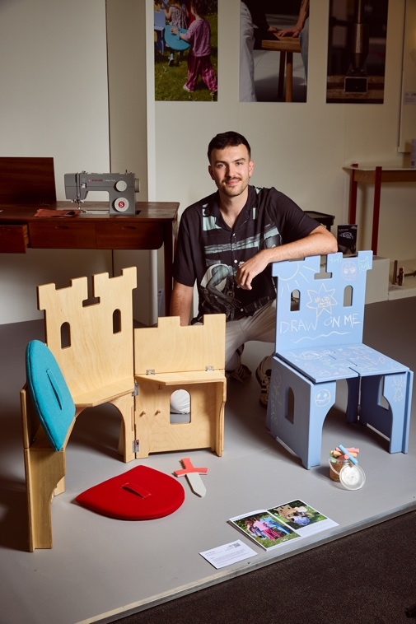
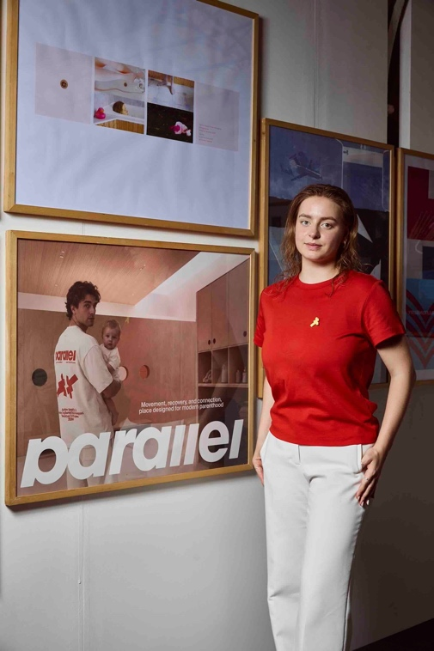
Judges described the chair as "beautifully proportioned and thoughtfully resolved, ready to sit alongside today's leading minimalist furniture designs."

Above (from left): James Murphy from Nottingham Trent University, winner of the Habitat Furniture Award, and Uliana Shuba from Cambridge School of Visual & Performing Arts, winner of the Affinity Design Award

Habitat Future Design Award
James Murphy of Nottingham Trent University won the Habitat Future Design Award for Casul Chair which is a transformable chair and playset for children that provides an interactive analogue play and experience that encourages imagination. From fort building and role playing to storytelling and drawing, Casul is a fun imaginative piece of furniture that supports children developmentally through play.
Habitat's Head of Buying, Georgina Dawson, said: "James presented a thoroughly considered project that consistently put the end user first. We were particularly impressed by the way he balanced playfulness with functionality."

Affinity Design Award
The Affinity Design Award was presented to Uliana Shuba of Cambridge School of Visual and Performing Arts for Parallel, an active gym space for children that enables parents to stay connected to fitness, wellbeing and community during early parenthood. Judges praised the project for its exceptional refinement, craftsmanship and design sensibility, highlighting Shuba's ability to clearly articulate creative decisions while embracing emerging technologies.
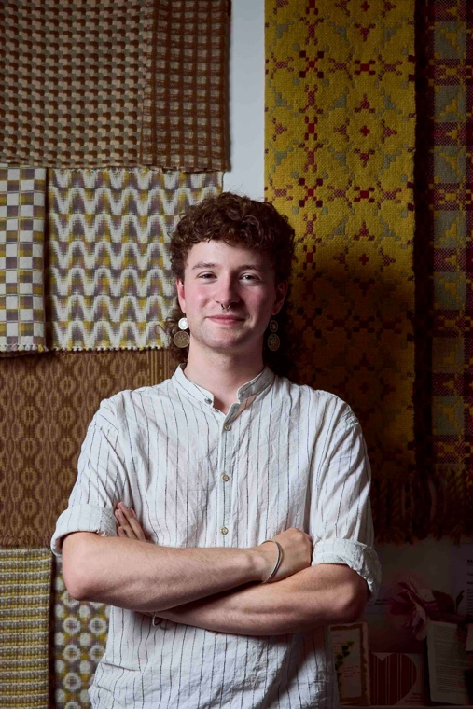
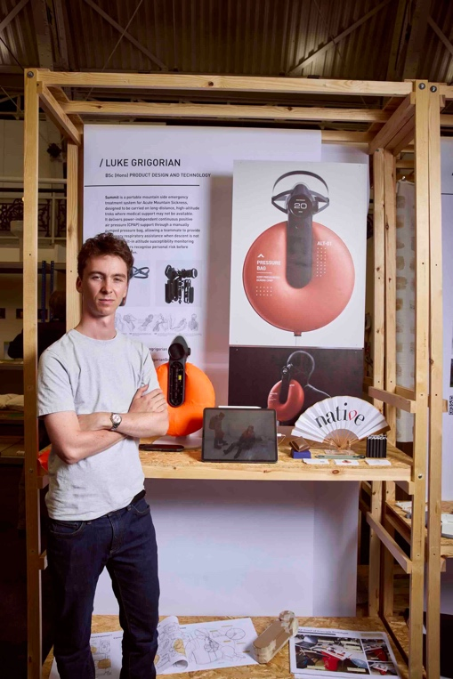

Above (from left): Twig Searle from Falmouth University, winner of The Sanderson Award, and Luke Grigorian from Loughborough University, winner of The Future Native Award.

The Sanderson Award
Twig Searle of Falmouth University received The Sanderson Award for a contemporary interpretation of traditional Welsh blanket weaving. Developed over the course of the designer's degree, the body of work draws inspiration from a fairy tale about a dyer who loses access to all of his trade routes and is forced to rediscover his craft using only the natural resources available within a five-kilometre radius of his home. By foraging locally for natural dyes and materials, the project explores themes of resilience, resourcefulness and reconnecting with traditional making practices, revealing that what was thought to be lost had simply been forgotten.
Judges commented on the work's outstanding craftsmanship, thoughtful storytelling and commitment to natural dyeing and sustainable textile practice.

The Future Native Award
Luke Grigorian received The Future Native Award for Summit, a portable emergency treatment system for acute mountain sickness.
Inspired by his own experience as a keen hiker, Luke identified a gap in the market for an emergency treatment device that operates without electricity or oxygen. Judges praised the project for its holistic design thinking, innovation and meticulous attention to detail within a highly challenging design space.
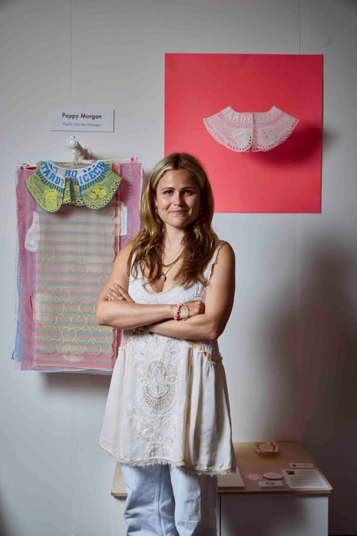
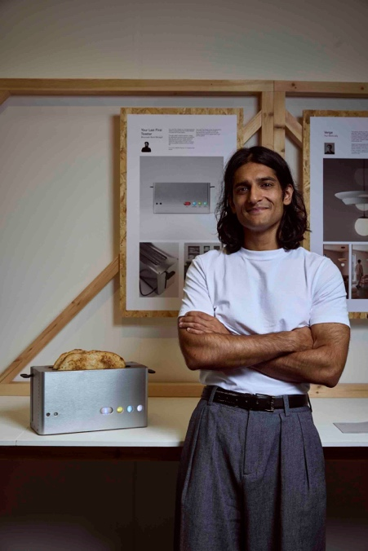

Above (from left): Bhavnesh Rohit Modgill from the University of Brighton, winner of the Joseph Stannah Award, and Poppy Morgan from Edinburgh University, winner of the Oliver Bonas Award for Creativity & Originality in design

Joseph Stannah Award
Bhavnesh Rohit Modgill of the University of Brighton received the Joseph Stannah Award for Toaster, an inclusive domestic appliance inspired by his experience of living in an intergenerational household.
The project reimagines the everyday toaster through the principles of accessibility and sustainability. Designed to appeal to first-time homeowners, it incorporates intuitive controls, tactile markers, high-contrast colours and modular construction, acknowledging that accessibility requirements evolve throughout life without compromising aesthetics.
Alex Wilson, Product Director of Stannah, commended the project for its excellent research, thoughtful development and compelling presentation.

Oliver Bonas Award for Creativity & Originality in Design
Poppy Morgan of Edinburgh College of Art won the Oliver Bonas Award for Creativity & Originality in Design for Playful, Lace-like and Nostalgia.
Drawing on family history, personal storytelling and the tradition of lace-making, the collection transforms sentimental memories into joyful embroidered sculptural collars. References to everyday family rituals and iconic Heinz Tomato Ketchup branding are reinterpreted through contemporary embroidery, creating work that feels both playful and deeply personal.
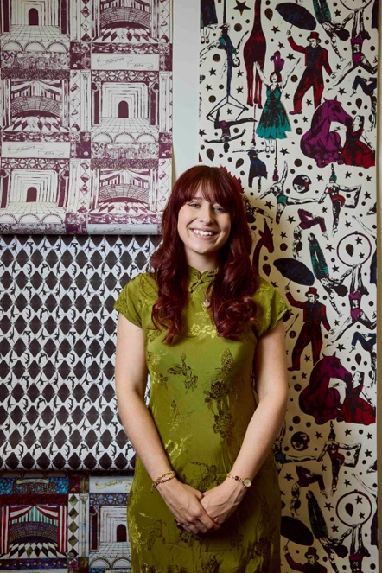
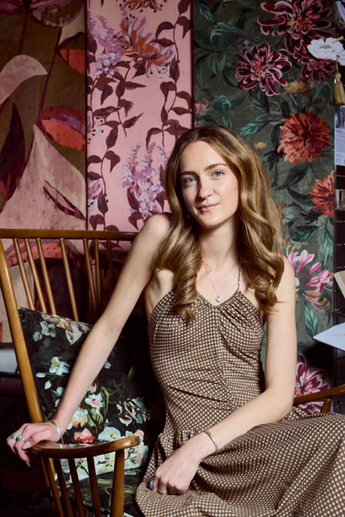
Judges described the project as “a beautifully considered exploration of reimagined lace, successfully combining nostalgia, humour and craftsmanship in a fresh contemporary context.”

Above (from left): Grace Holden from Heriot-Watt University, winner of the Laura Ashley Lifestyle Award, and Lauren Stokes from Swansea College or Art, winner of the Romo Award for Innovation in Design

Laura Ashley Lifestyle Award
Grace Holden of Heriot-Watt University received the Laura Ashley Lifestyle Award for Stories in Bloom.
The collection of luxury interior fabrics and wallcoverings explores how the meaning of home evolves from childhood through to adulthood. Inspired by Victorian floriography, each floral motif tells a different chapter of the story, while digitally printed wallcoverings preserve expressive brushstrokes and tactile fabrics add depth and warmth.
Grace said: "It's such a privilege to receive this award. It's a wonderful culmination of my time at university." Laura Ashley's judges praised the collection's strong commercial appeal and its ability to translate seamlessly into the Laura Ashley lifestyle.

Romo Award for Innovation in Design and Colour
Lauren Stokes of Swansea College of Art won the Romo Award for Innovation in Design and Colour for The Tale of Twynnoy and the Tiger.
Inspired by the story of Hannah Twynnoy, who was killed by a tiger in Malmesbury in 1703, the collection combines rich storytelling with hand-drawn artwork influenced by the decorative worlds of Mind the Gap and Fornasetti.
Lauren described the award as the fulfilment of a lifelong ambition, having hoped to collaborate with Romo since childhood.
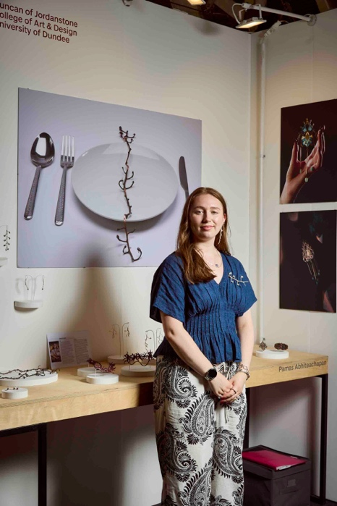
Romo’s Design and Brand Manager Becky Brown commented: “The vibrant wallcovering collection is original, with a compelling narrative and beautifully executed illustrations.”
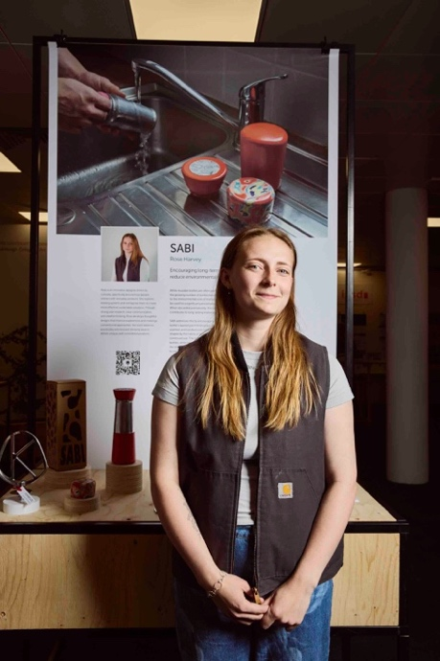

Above (left): Aurora Stevens from the University Of Dundee, winner of the Hockley Mint Jewellery Designer of the Year Awards, and Rose Harvey (right) from Edinburgh University, winner of the Kenwood Make It Big! Award

Hockley Mint Jewellery Designer of the Year
Aurora Stevens of the University of Dundee received the Hockley Mint Jewellery Designer of the Year Award for Black Vine Necklace. Her thought-provoking collection, which explores the relationship between food, nature and cultivation draws on her background in jewellery, design and metalsmithing. Aurora's work reconnects viewers with the natural origins of what we eat through intricate pieces created from leftover organic materials. Inspired by the lifecycle of plants and sustainable growing practices, her collection highlights the beauty found in overlooked natural forms while encouraging a deeper appreciation of the connection between people, the environment and the food they consume.

Kenwood Make It Big! Award
Rose Harvey of the University of Edinburgh won the Kenwood Make It Big! Award for Sabi Bottle, a reusable bottle designed to encourage long-term use through intentional care and an evolving visual design. Recognising that durable products must be used for many years to offset their environmental impact, Sabi promotes lasting ownership rather than replacement. The judges praised it as “a clever, well thought through sustainable product” with “great consideration to manufacturing as well as aesthetics.”
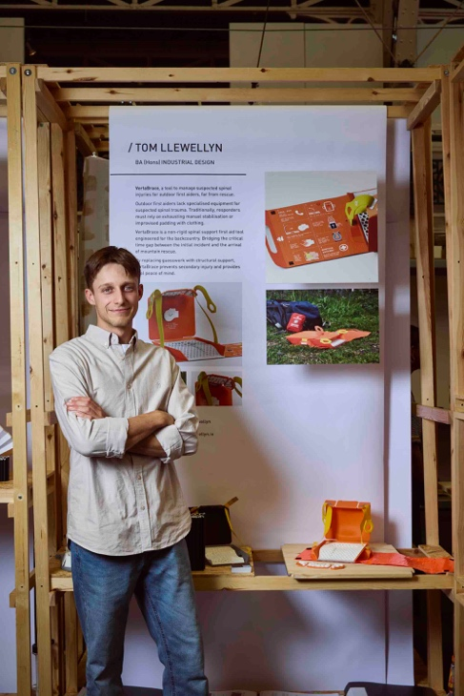
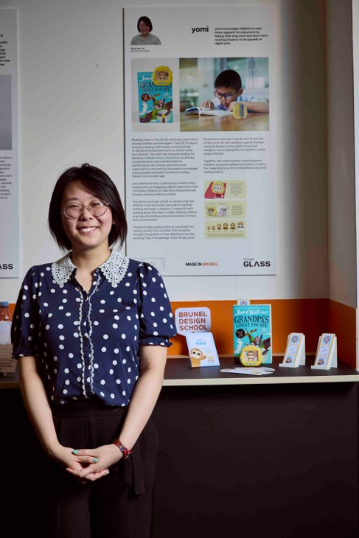

Above (from left): Wing-See Yau from Brunel University, winner of the Cadbury-Mondelez International Award, and Tom Llewellyn from Loughborough University, winner of the Joseph Joseph Intelligent Design Award

Cadbury-Mondelez International Award
Wing-See Yau of Brunel University won the Cadbury-Mondelez International Award for Yomi, an interactive reading companion designed to build children's confidence and enjoyment of reading.
The device features an integrated microphone that recognises each word spoken, rewarding progress by nurturing a virtual pet monkey over a 14-day reading journey. Wing-See said: "I'm extremely emotional to receive this award. All of the hard work has been worth it."

Joseph Joseph Intelligent Design Award
Tom Llewellyn of Loughborough University received the Joseph Joseph Intelligent Design Award for VertaBrace a tool to manage suspected spinal injuries for outdoor first aiders, far from rescue.
VertaBrace is a non-rigid spinal support first aid tool engineered for the backcountry. Bridging critical time gap between the initial incident and the arrival of mountain rescue.
Antony Joseph, Chief Creative Officer at Joseph Joseph, said: "Tom tackled a meaningful problem with an inventive, well-executed solution. This highly considered design combines practicality, portability, efficient use of space and the potential for life-saving impact."
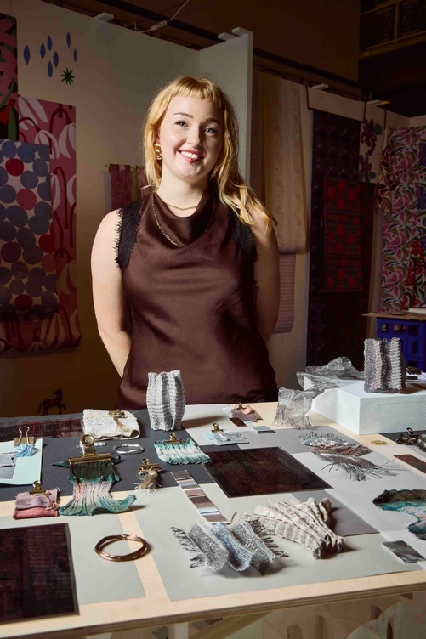
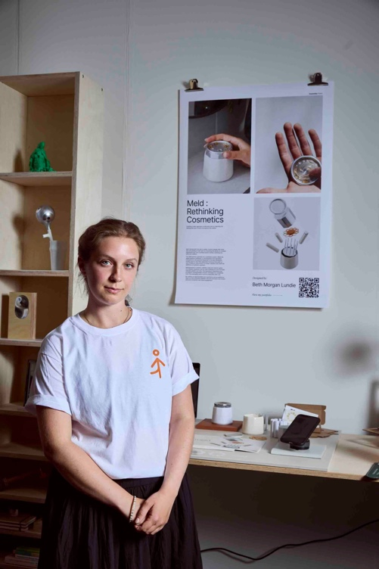

Above (from left): Beth Morgan Lundie from Assembly Point, winner of the PriestmanGoode Rising Star Award, and Laura Nunn from Manchester School of Art, winner of the Sage Automotive Passion for Textiles Award

PriestmanGoode Rising Star Award
Beth Morgan Lundie of Assembly Point won the PriestmanGoode Rising Star Award for Meld, an innovative cosmetics dispensing system.
The service enables users to combine skincare ingredients at the point of use, eliminating the need for many conventional preservatives while improving ingredient transparency and reducing waste.
Associate Directors Mike Davies and Maria Kafel-Bentkowska said: "Beth demonstrated an excellent understanding of the market alongside outstanding research into reuse, materiality and circular design. The project presents a genuinely holistic response to the brief."

Sage Automotive Passion for Textiles Award
Laura Nunn of Manchester School of Art received the Sage Automotive Passion for Textiles Award for Steel City. Steel City aims to explore the architectural, structured nature of woven textiles that feature wire in the weft and warp, in conjunction with the more organic, shapely properties of overspun wool.
Judges commented on Laura’s exquisite use of colour and innovation weaving techniques.

Hallmark Care & Connect Award
Illustrator Abi Jade of the Norwich School of Arts won for her project. The judges said: “Abi has a joyful energetic practice. Her work connects through tactility and playfulness, and there is a breath of multi-sensory visual storytelling in her unique illustrative world (and if we are allowed to say…it’s a little bit bonkers).”

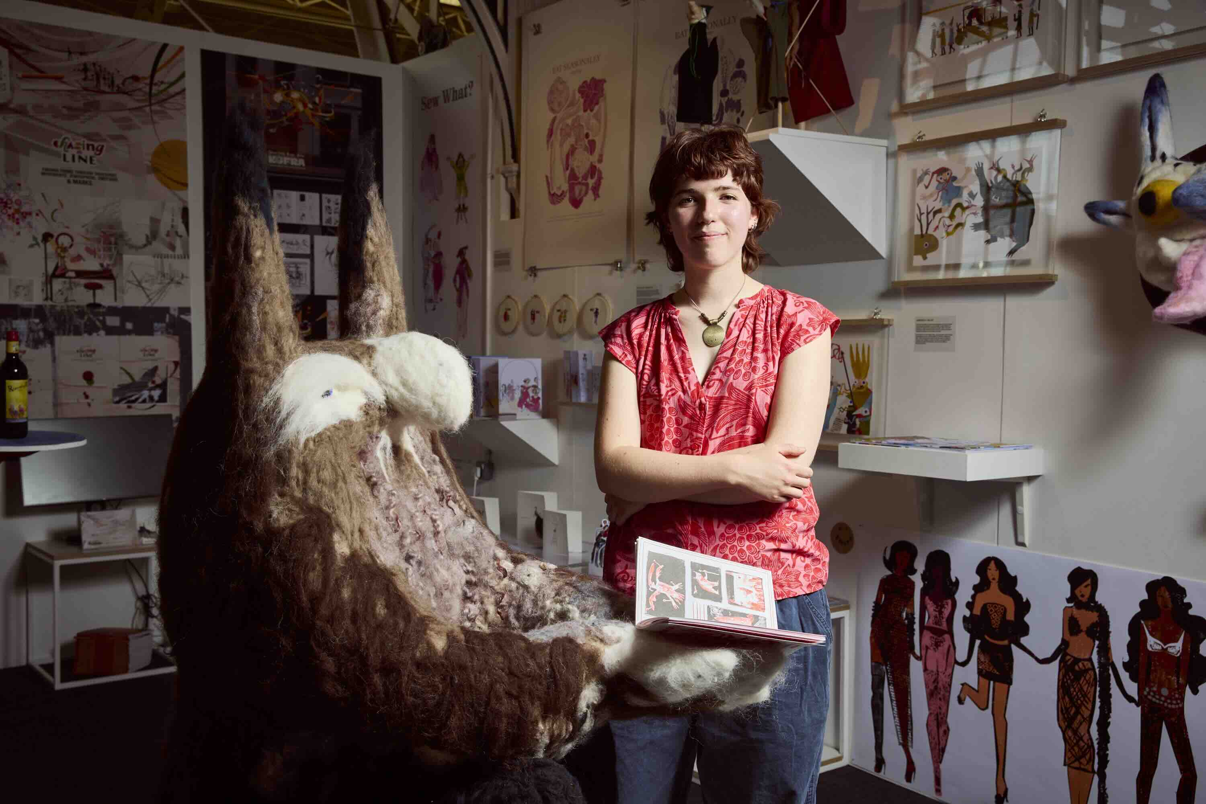

Runners Up

The Laura Ashley Lifestyle Award
Jessica Parker, Norwich University of Arts. ‘Treasure the Thoughts Collection are prints and surfaces capturing the warmth and familiarity of retro interiors and objects celebrating personal and emotional connections to the spaces we once called home.

The Spotlight Award Winners:

We Make Stuff Happen Award
Winner: Tilly Lawless, Brighton University
Project: Dress Made out of Festival Tents

Creative Review Award
Winner: Lucy Whiskens and Lily Truelove, Manchester School of Art
Project: World Cup Wall Chart, Scarf and Print

Amtico Design Futures Award
Winner: Alejandro Cogolludo-Blank, University of Leeds
Project: Sense – a set of earbuds that pairs sensory control input and grounding techniques to support the reduction of sensory overload and anxiety in neurodivergent students

Feldspar Studio Award for Material Mastery and Contemporary Craft
Winner: Lucia Olmeda, Morley College
Project: Sculptural Ceramic Vessel

Boodles Award
Winner: James Roach, Birmingham City University
Project: Bangle

The Alchemy Award (sponsored by Based Upon)
Winner: Amelia Dittmann, Loughborough University
Project: Textiles

Marks & Spencer Award
Winner: Grace Holden, Heriot Watt University
Project: Textiles

Ocee & Four Design
Winner: Elora Foley, Northumbria University
Project: Café chair

GF Smith Award
Winner: Megan West, Winchester School of Art
Project: Books / publications

Decorex Award
Winner: Walter Rose, Robinson Howe Studio
Project: Cabinet

Keyshot Award for Exceptional Design & Visual Communication
Winner: Sam Collins, Sheffield Hallam University
Project: Go-eat foldable dog bowl

Colour in Design Award
Winner: Florence Barnaby, Loughborough University
Project: Biodegradable tiles

Screening Prize for Aardman Academy
Winner: Tasha Montague, Nottingham Trent University
Project: Film – The Passage

Photography by: Mark Cocksedge

For further information, press enquiries and images, please contact:
Berna Sermet - berna@friendsandco.co.uk
Christine - christine@friendsandco.co.uk

NOTES TO EDITORS
On-the-Door Ticket prices:
Adult Day Pass £23.90 (£19.95 ticket + £3.95 transaction fee)
Concession Day Pass (Over 65+, Child age 14 – 16, Student ID) £16.95 (£13 ticket + £3.95 transaction fee)
Children (13 and under) Free of charge
All Access Pass (Including Awards Preview Evening & Multi-Day Access) £29.90 (£25.95 ticket + £3.95 transaction fee)
Thursday Late £13.95 (£10 ticket + £3.95 transaction fee)
Family Ticket (2 adults and one Child age 14 – 16) £43.95 (£40 ticket + £3.95 transaction fee)
Trade Ticket (Industry only) £11.95 (£10 + £1.95 transaction fee)
Transaction fee applies of £3.95 per order and £1.95 on trade tickets. Details below.

Opening times:
- Wednesday 1 July 12pm – 4pm (Awards judging and Trade only)
- Wednesday 1 July Awards Preview Evening 4pm – 8pm
- Thursday 2 July 10am – 5pm
- Thursday Late 2 July 4pm – 8pm (After Work Networking Drinks)
- Friday 3 July 10am – 5pm
- Saturday 4 July 10am – 4pm

About New Designers
New Designers is an annual showcase of the UK’s most innovative emerging design talent. Since its inception over 40 years ago, New Designers has provided a platform for over 3,000 graduates to present their visionary ideas to industry professionals and the public every year.

This year, the event takes place over one week, with different disciplines showcased spanning fashion, textiles, furniture, product design, illustration, and more. With a focus on creativity, innovation, and sustainability, New Designers is a must-attend event for anyone interested in the future of design. Whether you’re a design enthusiast, a student, or a professional in the industry, there’s something for everyone at New Designers.

Sponsors and Partners:
Affinity by Canva
Allermuir
AOI
Benchpeg
BIID
Business Design Centre
Buzzball
Cambridge Consultants
Clerkenwell Design Week
Cockpit
Colour in Design Awards
Creative Review
DBA
DCA
Design Burger
DesignWanted
Develop3d
Dezeen
Dolmen
GF Smith
Goldsmith’s Centre
Fashion United
Future Icons
Habitat
Hallmark
Imperial Brands
Intellectual Property Office
It’s Nice That
John Lewis
Joseph Joseph
Joint Design Direction
Kenwood
Keyshot
Laura Ashley
London Design Festival
M&S
Materials and Design Exchange
National Association of Jewellers
Native Design
Oliver Bonas
Opus Magnum
Queen Elizabeth Scholarship Trust
People of Print
Premier Digital Textiles
ReFAB Studio
Romo
Sage Automotive Interior
Sanderson Design
Seymourpowell
Shoreditch Design Week
Society of Designer Craftsmen
Stannah
The Cloth Workers Company
The Conran Shop
The Weavers Company
Tom Faulkner
Unique Style Platform
Visual Artists Association
We Make Stuff Happen
WGSN
Wilcom

